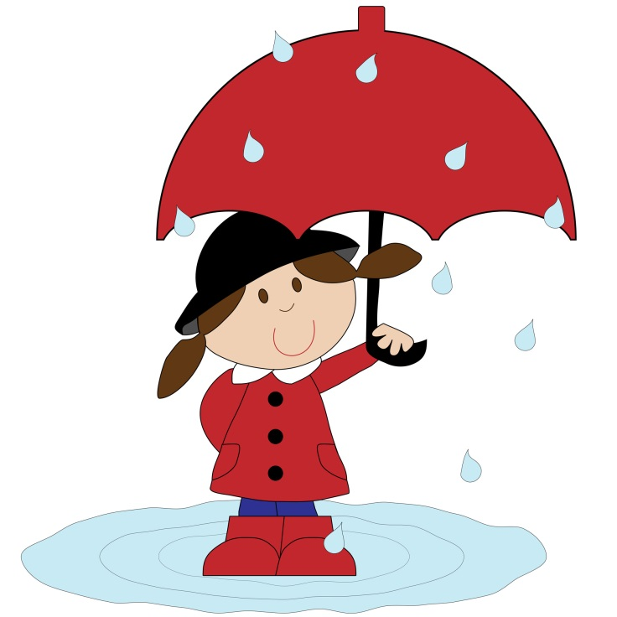
April showers bring May flowers. Here are fun and simple activities to do with the family. They will help you expose your child to appropriate vocabulary and concepts every day of the month. The activities require very little planning and can be easily completed in and around the home. Please take time to enjoy these fun activities with your child!

APRIL
Sunday | Monday | Tuesday | Wednesday | Thursday | Friday | Saturday
Talk about the important dates in April (holidays, birthdays, etc.) | Make a fancy sandwich by cutting it into different shapes. | Talk about different animals people have as pets. | Look outside and find things that are brown. | Find rectangles in the kitchen. | Make a tent using a sheet and furniture. Pretend to go camping. | Stretch to be tall, narrow, and long. Scrunch down to be short, wide, small.
Take turns scooping sand with your hands and filling up a bucket. | Clean the bathtub using a variety of scrubbing motions (e.g., circular, zigzag). | Make ice cubes using fruit juice instead of water. | Talk about words that rhyme with cat. | Name your ancestors and talk about how they lived. | Draw a picture of your house. | Count all the doors and windows in the house.
Go to a store and buy fruit. Talk about their shape, color, taste, where and how they grow. | Write with colored pens and name the different colors. | Talk about things you can ride in (e.g., cars, wagons, airplanes, buses, trains). | Read a book about animals and look for the smallest ones. | Name your friends and their pets. | Talk about different types of furniture in a bedroom. | Sort the books in the house into two piles: big books and little books.
Name the appliances in the house (e.g., washer, dryer, stove, vacuum cleaner, refrigerator). | Look under furniture and talk about what you find. | Watch the clouds move across the sky. Talk about the shapes they look like. | Look outside and talk about the birds you see. | Talk about signs of danger (e.g., smoke coming from a house, sirens blaring). | Go for a bike ride and talk about bike safety. | Collect sticks outside and arrange them by length.
Visit a museum and talk about the exhibits. | Talk about things that help people stay dry (e.g., raincoat, galoshes, umbrella). | Help your child draw shapes on paper. Name each shape. | Look in a magazine or newspaper and draw circles around the numbers. | Talk about the signs of spring. | Draw a family picture. Talk about who is tallest, shortest, oldest, youngest. | Look back at this month’s calendar. Talk about the important things that happened.

